**DAYANANDA SAGAR COLLEGE OF ENGINEERING**

(An Autonomous Institute affiliated to VTU, Belagavi, Approved by AICTE & ISO 9001:2008 Certified)

Accredited by National Assessment & Accreditation Council (NAAC) with ‘A’ grade, Shavige Malleshwara Hills, Kumaraswamy Layout, Bengaluru-560078.



**SEMINAR REPORT**

**on**

**“On remote temperature sensing using commercial UHF RFID tags”**

Submitted By

**K R Vadiraj**

**[1DS16CS131]**

**[Eighth Semester B.E (CSE)]**

**2019-2020**

Under the guidance of

**Dr. Amutha N**

**Professor**

**Dept. of CSE**

**DSCE, Bangalore**

**Department of Computer Science and Engineering**

**Dayananda Sagar College of Engineering Bangelore-78**

**VISVESVARAYA TECHNOLOGICAL UNIVERSITY, BELGAUM**

**DAYANANDA SAGAR COLLEGE OF ENGINEERING**

**Shavige Malleshwara Hills, Kumaraswamy Layout, Bangalore-560078**

**Department of Computer Science & Engineering**



**CERTIFICATE**

This is to certify that the seminar work entitled **“**On remote temperature sensing using commercial UHF RFID tags” is a bonafide work carried out by K.R.Vadiraj [1DS16CS131] in a partial fulfilment for the 8th semester of Bachelor of Engineering in Computer Science and Engineering of the Visvesvaraya Technological University, Belgaum during the year 2019-20. The seminar report has been approved as it satisfies the academic requirements in respect of Seminar Work prescribed for Bachelor of Engineering Degree.

**Signature of Examiners with date Signature of HOD**

**Acknowledgement**

Thanking the HOD and guide for providing us with the necessary resources required in the completion of the project. Special thanks to Dr.Vindhya for ensuring smooth co-ordination and conduction of phase reviews and for the constant support.

**K R Vadiraj**

**[1DS16CS13]**

**Abstract**

With the ever-growing technological innovations of Radio frequency Identification (RFID) technology RFID based sensors have attracted great interest in the commercial market. Due to the limitations of RFID tags, most existing RFID based temperature sensing works rely on hardware tweaks which result in the increase in costs and hampers large scale development in industries. In this paper we propose RFThermometers, a remote temperature sensing system with commercial ultra-high-frequency (UHF) tags. We first investigate the affect of temperature on RFID phases. To nullify the precision deterioration caused by the missing phase readings a tensor completion method is proposed to restore missing phases and a Gaussian model is leveraged to construct a phase-temperature map in the offline stage. In the online stage the unknown temperature is estimated by dynamic time warping (DTW) based greedy method. Extensive experimental results are showcased to validate the performance of RFThermometer with the off-shelf RFID devices.

**1.Introduction**

With rapid development of passive radio-frequency identification (RFID) technology RFID tags have been widely used and deployed in multiple fronts such as supply chain management, access control, card authorization and inventory tracking. Due to ubiquitous employment, ease of deployment and low cost RFID tags it has been possible and feasible to extend the use of this technology to healthcare monitoring and environmental sensing. The drastic growth of Internet of Things (IoT) RFID systems have attracted great interest and use in industries and for research purposes.

Current RFID based temperature systems depend on modified RFID tags. General sensors can be embedded inside the tags to make it detect temperature ranges from (-40 to 80 degrees Celsius). The main drawback is that these sensors could be only used at 134.2 kHz. The experiments show that the operations range of such tags can be limited to a distance of 25 cm with a square antenna (80X100mm). To overcome this limitation we propose a system making use of UHF RFID tags.

This design achieves a temperature resolution of 0.035º C with a temperature range of 35º C to 45ºC. Even though the sensors provide an accurate and reliable reading the cost of tags and customer spending increases which adversely affects large scale use.

**2.Literature Survey**

[1] Shao, Shuai, et al. “Broadband Textile-Based Passive UHF RFID Tag Antenna for Elastic Material.” *IEEE Antennas and Wireless Propagation Letters*, vol. 14, 2015.

RFID uses radio frequency waves to interact with the RFID tag. The RFID tag gets activated only when the RFID scanner is nearby around 10 to 20cm. The commercially available RFID tag are not very flexible and this effects the durability. This paper talks about how more flexible textile-based RFID tag can be implemented. The commercially available RFID tag antennas work in UHF (Ultra High Frequency) spectrum range. This spectrum range is defined from 952 to 954 MHz The widely used high-powered systems using a passive tag can use an antenna whose power is between 10 mW to 1 W and an antenna gain defined by the power transmitted by the antenna in a particular direction can be of 6 dBi.

By using a flexible and textile based RFID tag antenna it was demonstrated that the antenna achieves a bandwidth of 263MHz in free space and it also maintains its tuned behavior when the tag is placed in dielectric medium. The performance of the designed tag was also observed and it was concluded that the tag does not degrade under mechanical deformation up to 10%, which good evidence that the tag can handle hostile environments.

[2] Scherhaufl, Martin, et al. “UHF RFID Localization Based on Evaluation of Backscattered Tag Signals.” *IEEE Transactions on Instrumentation and Measurement*, vol. 64, no. 11, 2015.

In this paper the localization of the RFID is based on evaluation of backscattered tag signals. By combining phase and amplitude evaluation the accuracy and the robustness of the estimation of tag position if improved compared to the approach of using either one of them. The passive RFID transponder which is used to estimate the position of the tag communicates its information by means of backscatter modulation, where the reflection coefficient of the tag antenna is switched between two stages in accordance with the data being sent. Hence the localization can achieve based on PoA and amplitude as these parameters rely on the position of the RFID transponder. Furthermore, the algorithm used here does not rely on reference transponders.

[3] Scherhaufl, Martin, et al. “Robust Localization of Passive UHF RFID Tag Arrays Based on Phase-Difference-of-Arrival Evaluation.” *2015 IEEE Topical Conference on Wireless Sensors and Sensor Networks (WiSNet)*, 2015.

The RFID localization system used here rely on phase evaluation of the tag response signal. This evaluation is represented using the term phase of evaluation (PoA). A multiple input multiple output system is designed which consists of each frontend is configured to work as transmitter and the remaining frontend is configured to work as receiver. The measurements were carried out in an indoor office. A 2D representation of the position measurement was demonstrated for the passive RFID tags based on PoA evaluation of the signals. The ambiguity in the phase measurement is handled by arranging tags in a uniform linear array to simultaneously estimate its position.

**3.Present Technology**

To exploit the characteristics of tags using temperature some use paraffin wax as a substrate material for heat sensing. Considering the physical properties of this substance the changes of this layer due to the effect of temperatures is irreversible even though the temperature of the tag can be brought back to normal. Thus the modified tag does not serve this purpose.

Zannas et al also demonstrated the effect of temperature on the material characteristics of RFID tag. They propose that the relative permittivity of the antennas and the tags can be changed by temperature. Thus, making the complex impedance of the tag is a function of temperature. Furthermore to maximize the efficiency they propose the use of self-tuning circuits . To achieve optimization specific tags are essential. Therefore, this supports the fact that there is a strong demand for a temperature estimation system using generic, low cost UHF RFID tags.

**4.Proposal and Contribution by the paper**

This paper proposes to use unmodified commercial RFID tags for remote temperature sensing. This system is cost-effective as it integrates advanced signal processing /machine learning algorithms such as tensor completion and Gaussian Process, to ensure high accuracy and robustness.

The testing environment consists of refrigerated warehouses and refrigerated retail display cases etc where the RFID tagged items are stationary against the RFID readers and antennas in most of the times. The position of the antennas and tags are fixed in most test scenarios. This makes sure that the relative distance b/w them does’nt affect the phase readings of backscattered signals.

The most generic challenge being tackled is the collision of multiple UHF signals from multiple tags.To avoid this problem slotted ALOHA based anti-collision protocols are used. The RFID tags operate on a large frequency range at around 902~928 MHz in the US and is divided into 50 non-overlapping channels. Phase reading loss in a channel is inevitable in a complex environment.

The given tag interrogates tags with 50 channels in sequence and takes about 0.1 s in each channel. This means that it has to wait 5s to acquire the next set of information from the same channel.

The 2 main contributions of this paper are:-

1)Design of a gaussian process model to regress the relationship between phase and temperature as well as a DTW based greedy method.

2)Implementing a RFThermometer system with commercial RFID tags, antennas and readers.

The results by obtained solidify the robustness and flexibility of the proposed system

**5.Preliminaries**

*A Passive RFID and Phase-Temperature Relationship*

Passive RFID chips are embedded into the tags which solely rely on backscattering to communicate with the readers. The chip on the passive RFID tag harvests energy from the received interrogating signal sent by the reader and responds by varying its input impedance and thus modulating the backscattered signal with ON-OFF keying.

The power transmission coefficient is given by-



Where Rc,Zc,Ra and Za are the chip resistance and impedance, the antenna resistance and impedance respectively.

The power transmission coefficient reaches maximum when the chip impedance and antenna impedance are conjugately matched. We interrogate a single RFID tag over a temperature range of 50ºC to understand the relation bw phase scattered signals and temperature of the tag.

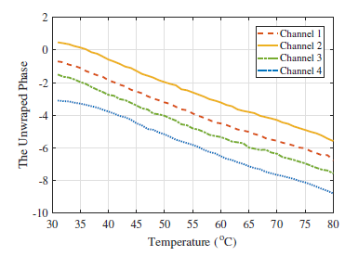

The above graph depict a linear relationship bw them.

B.*Tensor Completion Preliminaries*

Low Rank tensor-completion estimation is a sought after topic for research. It has mainly been used in Fourier domain. Based on the t-product ,the t-svd of M is defined as



Where the size of the tensor is a1 x a2 x a3; u and v are orthogonal tensors of size a1 x a2 x a3 and a2 x a2 x a2 xa3

Series of matrix operations are applied to estimate the tensor values.

**6.The RFThermometer system**

In the proposed system, RFThermometer is a fingerprinting based remote temperature sensing system which operates on two stages online and offline respectively. The FX9600 reader is able to collect phases from 50 channels within a period of 5 seconds .We denote data collected in one reading cycle as an observation which include phases collected from channel 1-50.

Because the dynamic environment and the number of tags, it is usually inevitable to lose phase readings in some channels which hurt our temperature prediction precision. To overcome this we they have proposed a tensor completion system to recover lost phases.

Multi linear Gaussian Process (MLGP) is also popular machine learning algorithm in data recovery, but it depends on the optimized hyper-parameter to achieve the best performance in regression. Although tensor completion and Gaussian process employed in the offline stage, their relatively high time complexity does not affect the user experience in the online stage.

Apparently, the tensor completion could recover the lost phases accurately and more reasonable values are obtained compared to the gaussian model.

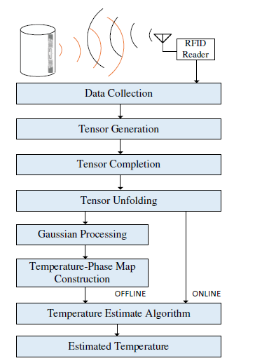

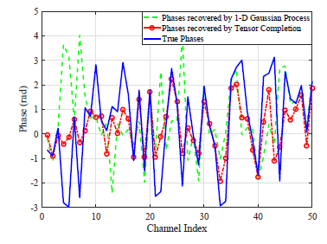

Thus the tensor completion is used in our RFThermometer system for better precision of phase recovery.

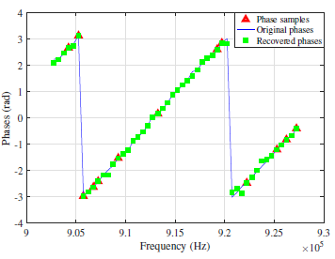

In the above figure all the green stars(restored phases) are on the blue line which means that the missing phases are successfully restored with only 30% of known phase samples.

*Gaussian Processing fir generating phase-Temperature Map*

To model the relationship between phase and temperature on each of the channels, we propose to employ Gaussian Process.

In RFThermometer, the phase value is given by

*θ*(*t*) = *p*(*t*) + *δ* + *ζ,*

where *θ*(*t*) is the measured phase at temperature *t*, *p*(*t*) is the true phase at temperature *t*, *δ* is the hardware offset, and *ζ* is the thermal noise. Consider two phase readings *θ*(*t*1) and *θ*(*t*2) obtained for temperatures *t*1 and *t*2, respectively. They have a joint Gaussian distribution with covariance *k*(*θ*(*t*1)*,θ*(*t*2)). In our system, we choose the squared exponential function as kernel function, which is defined as

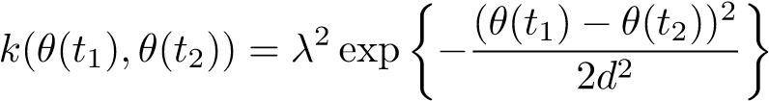

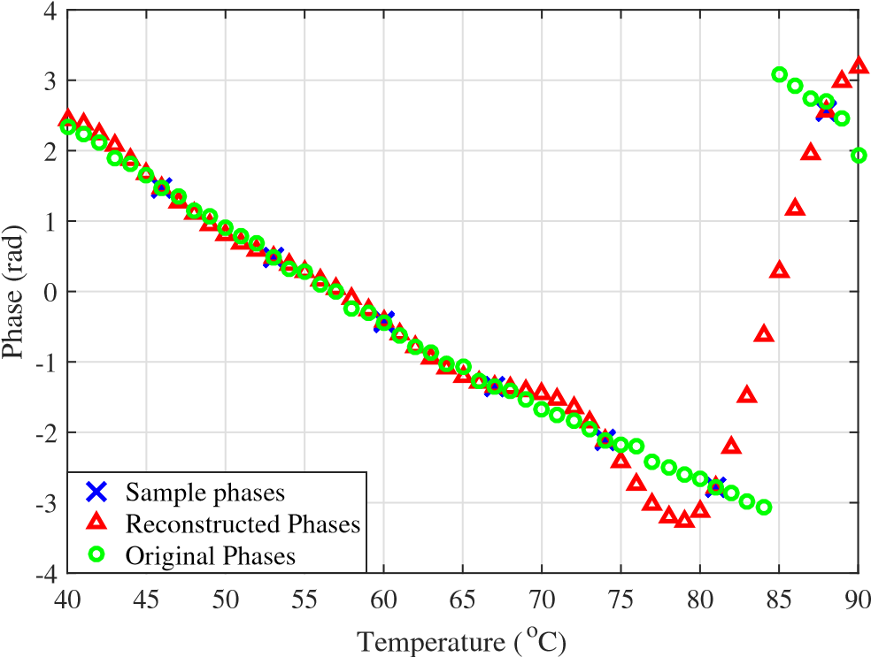

Most errors occur when the temperature is close to 80◦C, because the phase rotation happens at this temperature for channel 48 (i.e., a sudden jump from −*π* to *π*)

## 7.Impact of Various Design Parameters

*Impact of Tensor Completion*

50

40

30

20

10

0

1

2

3

4

5

6

7

Temperature Error (

o

C)

completio

n

With tensor

Without ten

sor compl

etion

*Impact of the Number of Observations of Training Tensor:*

All phase tensors include phases collected from 39◦C, 46◦C, 53◦C, 60◦C, 67◦C, 74◦C, 81◦C, and 88◦C. Thus, the temperature error is not greatly affected by the increasing number of observations.

4

6

8

10

20

30

40

50

3

0

1

2

3

4

5

6

7

Temperature Error (

o

C)

*Impact of the Percentage of Deleted Phases in the Training Tensor*

They next design a specific experiment by setting different percentages of deleted phases in each channel to evaluate their impact on temperature error. Furthermore, 10%, 30%, 50%, 70%, 90% phases in each observation are deleted to investigate the impact of missing phases. When the percentage of deleted phases is 90%, the temperature error escalates to 9.0◦C.

10

%

90

%

30

%

50

%

70

%

0

2

4

6

8

10

12

Temperature Error (

o

C)

*Impact of the Number of Tags*

Here we employ 1, 5, 10, 15, and 20 tags in the interrogating area to mimic a multiple-tag environment. When the number of tags in the interrogation area is increased, the number of phase readings in each channel decreases significantly. When 20 tags are within the interrogation area, the average number of available phase samples drops to 4.38. This demonstrates that demonstrates that the RFThermometer system is able to provide a reliable temperature estimation in a multiple-tag environment.

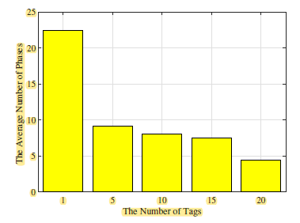

**Conclusion**

To mitigate the effect of missing phases, a tensor completion based method was employed to restore the missing phases. The RFThermometer system also employed Gaussian Process to construct a phase-temperature map with the phases restored by tensor completion in the offline stage, and a DTW based greedy method to estimate the unknown temperature in the online stage. The experimental results showed that RFThermometer was capable of building reliable phase-temperature maps with only a small amount of phase measurements, and that tensor completion effectively improved the temperature estimation precision.